**DBMS LAB-06(23-01-2025)**

**Name-** Bhavya Shrivastava **Roll No-** 23052071 **Section-** CSE-15

1. **Create and populate the following table ‘EMP06’. Make Emp_no the primary key and F_name not null.**

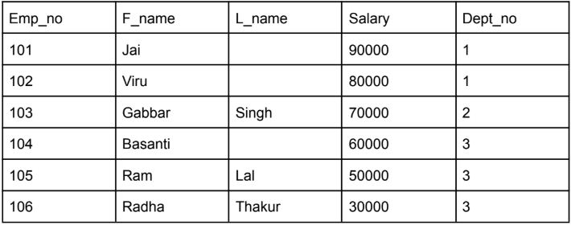

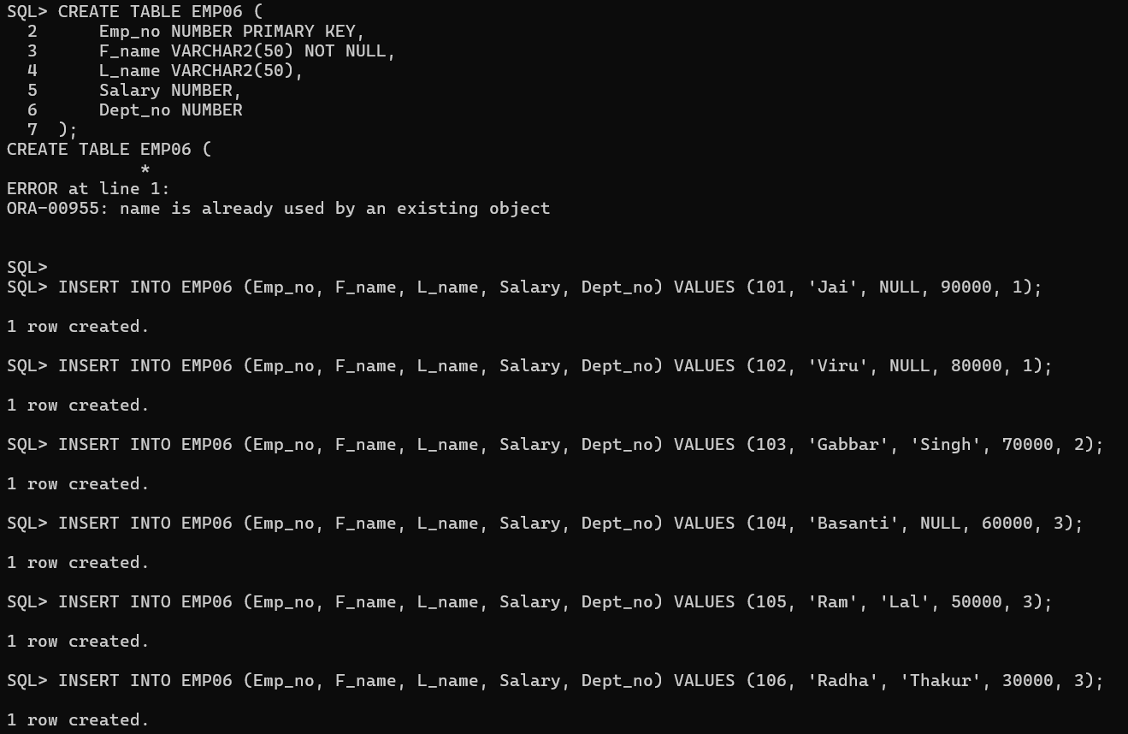

1. **Create and populate the following table ‘PROJECT’. Make P_no the primary key and put a default value constraint on P_Loc with value = ‘Mumbai’.**

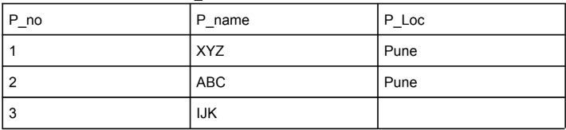

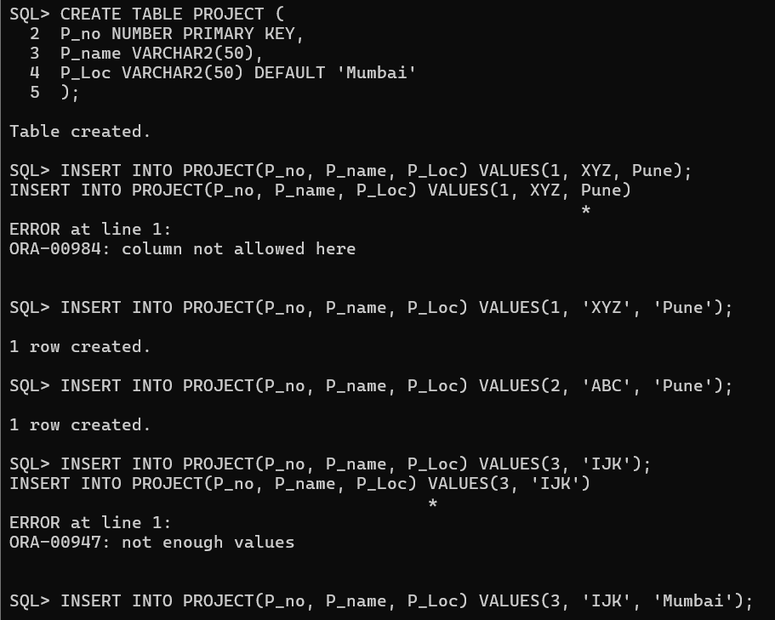

1. **Create and populate the following EMP_PROJ table. Make (Emp_no, P_no) the primary key.**

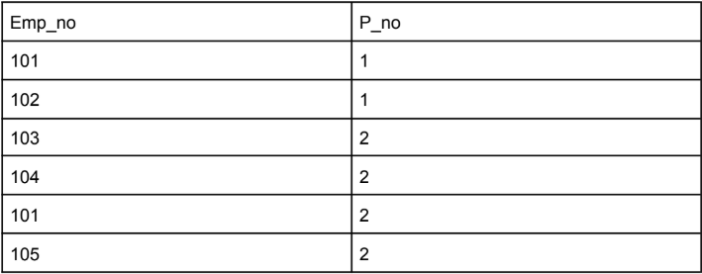

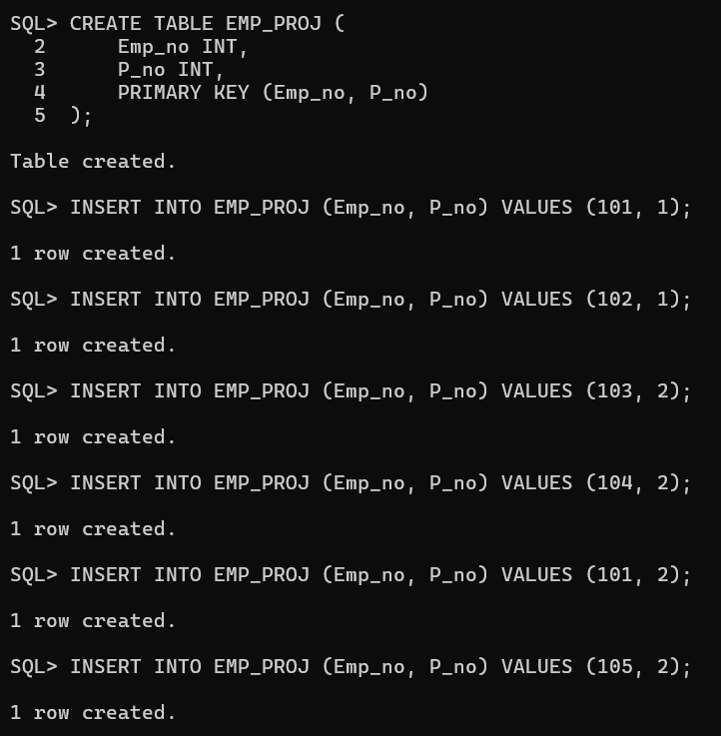

1. **Display the employee’s first names with the project name’s they are working on.**

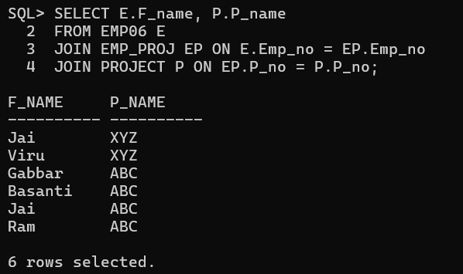

1. **In which city Gabbar Singh works.**

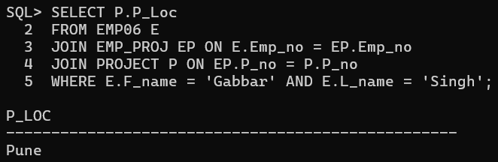

1. **Find the employee names who are not yet assigned to any project (using minus).**

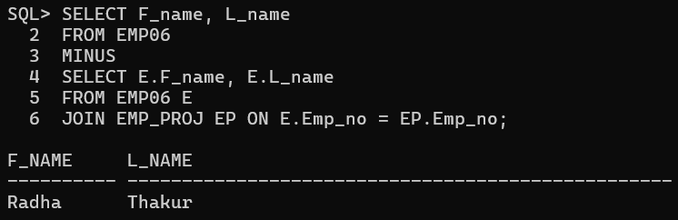

1. **Find the employee names who are not yet assigned to any project (using outer join).**

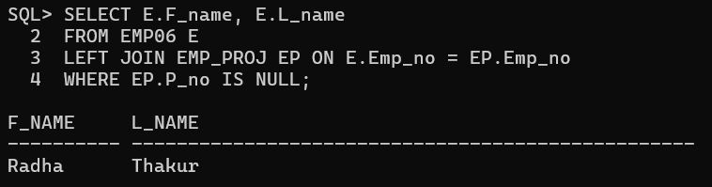

1. **Find the project names where no employees are working (using outer join).**

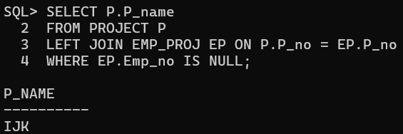

1. **Find all the employee names who are working in project number 1 and project ‘ABC’ (using union).**

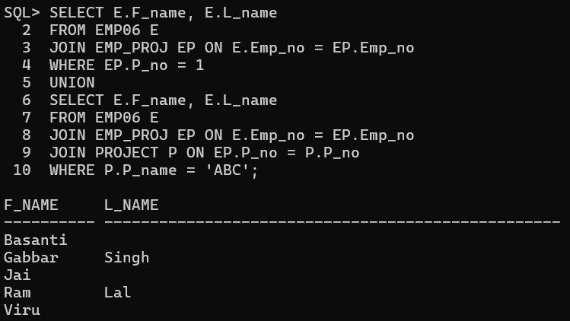

1. **Find all the employee names who are working in both project number 1 and project number 2 (using intersect).**

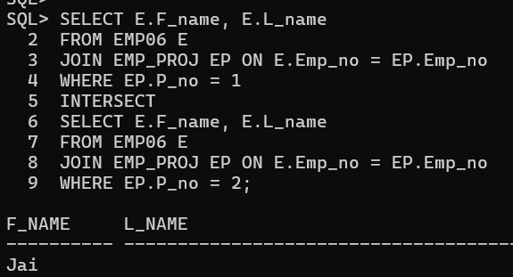

1. **Find the number of employees working in each project.**

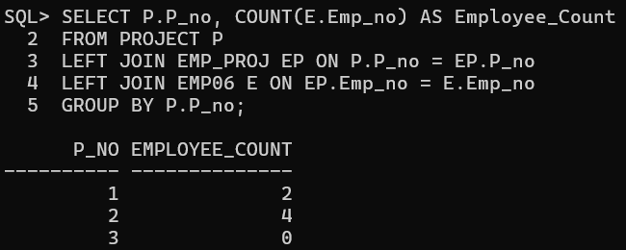

1. **Find the average salary of each department.**

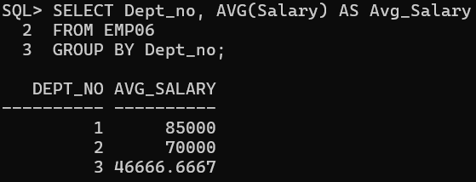

1. **Find the department number with the number of employees working in each department where the average salary is greater than 60000 and number of employees greater than 1.**

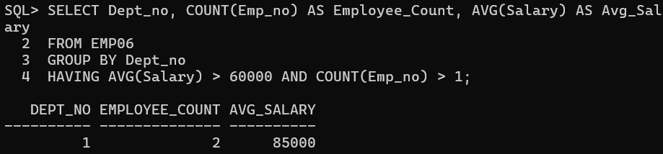

1. **Find all the employees who earn more than Basanti.**

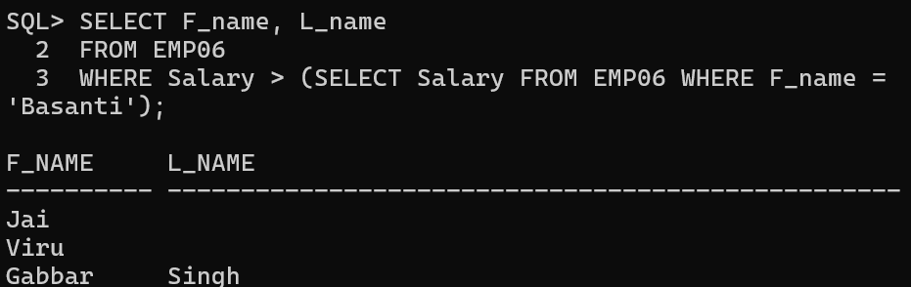

1. **Find all the employees who earn more than the average salary of all employees.**

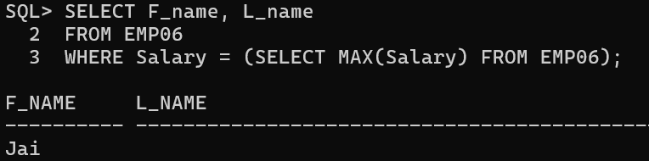

1. **Find the employee who earns the highest salary.**

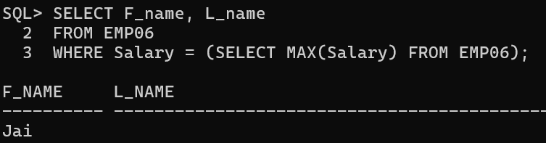

1. **Find the employee who earns the highest salary in dept_no 3.**

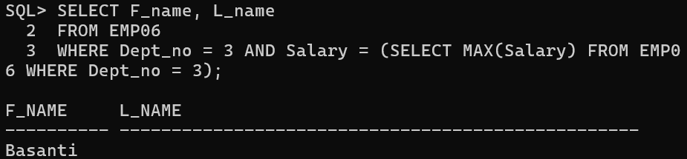

1. **Find the employee earning the second highest salary.**

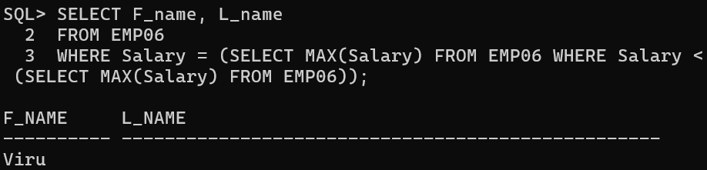

1. **Find the dept_no having the highest average salary.**

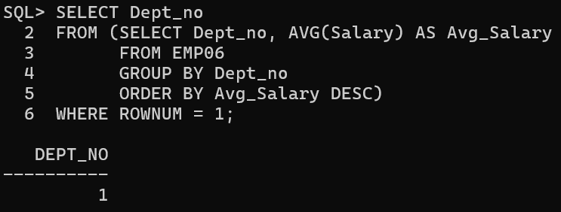

1. **Find the employee with the third highest salary among all the employees.**

